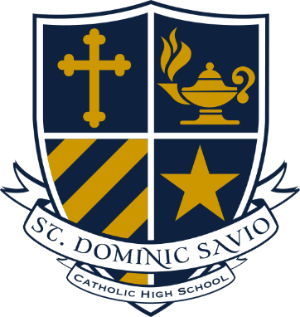
LEGACY SOCIETY
As evidence of my desire to provide a legacy of support to St. Dominic Savio Catholic High School, I am pleased to inform you that I intend to leave a gift to Savio in my estate plans. I understand that this commitment is revocable and can be modified by me at any time.
It is my intent to leave a legacy for the benefit of St. Dominic Savio Catholic High School (Please check all that apply).
- I have planned a bequest of $ from my estate to St. Dominic Savio Catholic High School in my will*.

- I have named St. Dominic Savio Catholic High School as the beneficiary of ___% of my estate.

- I have named St. Dominic Savio Catholic High school as the beneficiary of the reside of my estate*.

- The trustee of my Living or Charitable Remainder Trust* is instructed to distribute $________of the remaining corpus of the trust to St. Dominic Savio Catholic High School

Please enroll me in St. Dominic Savio Catholic High School's LEGACY SOCIETY under the following conditions:
- You have permission to publish my name in relation to LEGACY SOCIETY (print and internet) as a motivation for others to leave future gifts to benefit Savio.

- Please do not publish my name as a member of LEGACY SOCIETY (except on my personalized certificate).

Please proceed to the other side to complete this form.

Please PRINT your name exactly how you would like it to read in our donor listing on the line above.

Name (if different than above) Birthdate (MM/DD/YEAR)

Address: City State Zip

Home Phone Cell Phone Email address

Date Donor Signature

