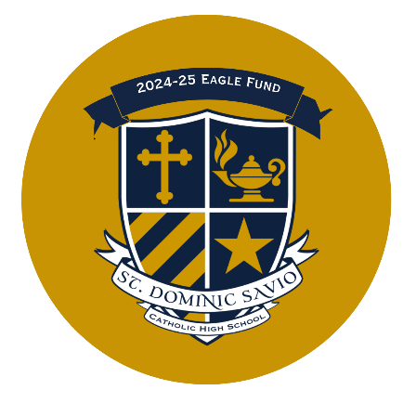

***Please use this guide to help you discern your gift***

***to the 2024-2025 Eagle Fund Annual Appeal.***

***Be prepared to submit your gift or commitment card during our***

***Week of Giving NEXT WEEK, October 7-11!***

As a Catholic community, we are called to sacrifice and pay it forward. St. Dominic Savio was founded on these principles, and we have upheld them for over 15 years, making us the thriving Catholic educational community we are today.

Each year, we ask for every family’s participation at some level in this appeal, as we understand that each family’s sacrifice looks different. Support of the Eagle Fund annual appeal is a testament to the commitment and support of the St. Dominic Savio community towards the value of a Savio education. It enables the school to maintain its operations, including competitive teacher salaries, tuition assistance, improved facilities, and investments in new resources and programs for our students across all subject and cocurricular programs, without placing the entire financial burden on tuition. The Eagle Fund helps bridge the gap between what each family pays per student in tuition and the actual cost of educating each student at Savio. **This year, the gap is $1,069 per student.**

As you discern your gift, you may find it helpful to note the following Eagle Fund Giving Levels:

***President’s Circle 15\*\*\****

***$15,000+***

***President's Circle Platinum\*\****

$10,000 – 14,999

***President's Circle Gold\*\****

$7,500-$9,999

***President's Circle Silver\*\****

$4,000-$7,499

***Leadership Society\****

$1,500 - $3,999

***St. John Bosco***

$750 - $1499

**Servant Leader**

$250 - $749

**Friends of Savio**

Up to $249

**Donor Appreciation Events**

**\* Leadership Society Gift = $1,500+**

Donors will receive an invitation to a special gathering with the Savio administration on Tuesday, November 12, 2024.

**\*\*President Circle Level Gifts start at $4,000+**

Donors receive an invitation to the Leadership Society event on November 12th AND an invitation to the President's Circle event to be held on Sunday, March 30, 2025.

All gifts can be made as a one-time gift or broken down over time as a “recurring gift” for as many months as you wish, or you can defer a one-time gift (as a pledge) using that option and setting the start and end date as the date you wish the transaction to run. You can also fill out a commitment card and turn it into the front office.

If you set up a recurring gift with no end date, any gifts received after June 30, 2025, will be applied to the following year’s appeal.

Lastly, If you work for an employer that has a matching gift program, please amplify your gift by submitting it for a corporate match. St. Dominic Savio is an educational entity and is eligible for corporate matching for all gifts made to the Eagle Fund. **Please note that all corporate matching gifts should be included in a family's giving totals on your commitment card.** You can communicate your matching gift by using the “Pledge Now” button instead of the “Give/Donate Now” button in our email or social media communications or by filling out a commitment card.

*Thank you for in advance for choosing to fully support your child's Catholic education with a gift to the Eagle Fund*. If you have any questions at all, please contact Gina Kerley, Director of Advancement at 512-244-4861.